**Đỗ Đình Tuấn – 21103100756 – DHTI15A1CL**

[**https://drive.google.com/drive/folders/1NF_ivCYHSYOssHVz9gzl9vPYTNz3Wm7o?usp=sharing**](https://drive.google.com/drive/folders/1NF_ivCYHSYOssHVz9gzl9vPYTNz3Wm7o?usp=sharing)

**Bài 1:**

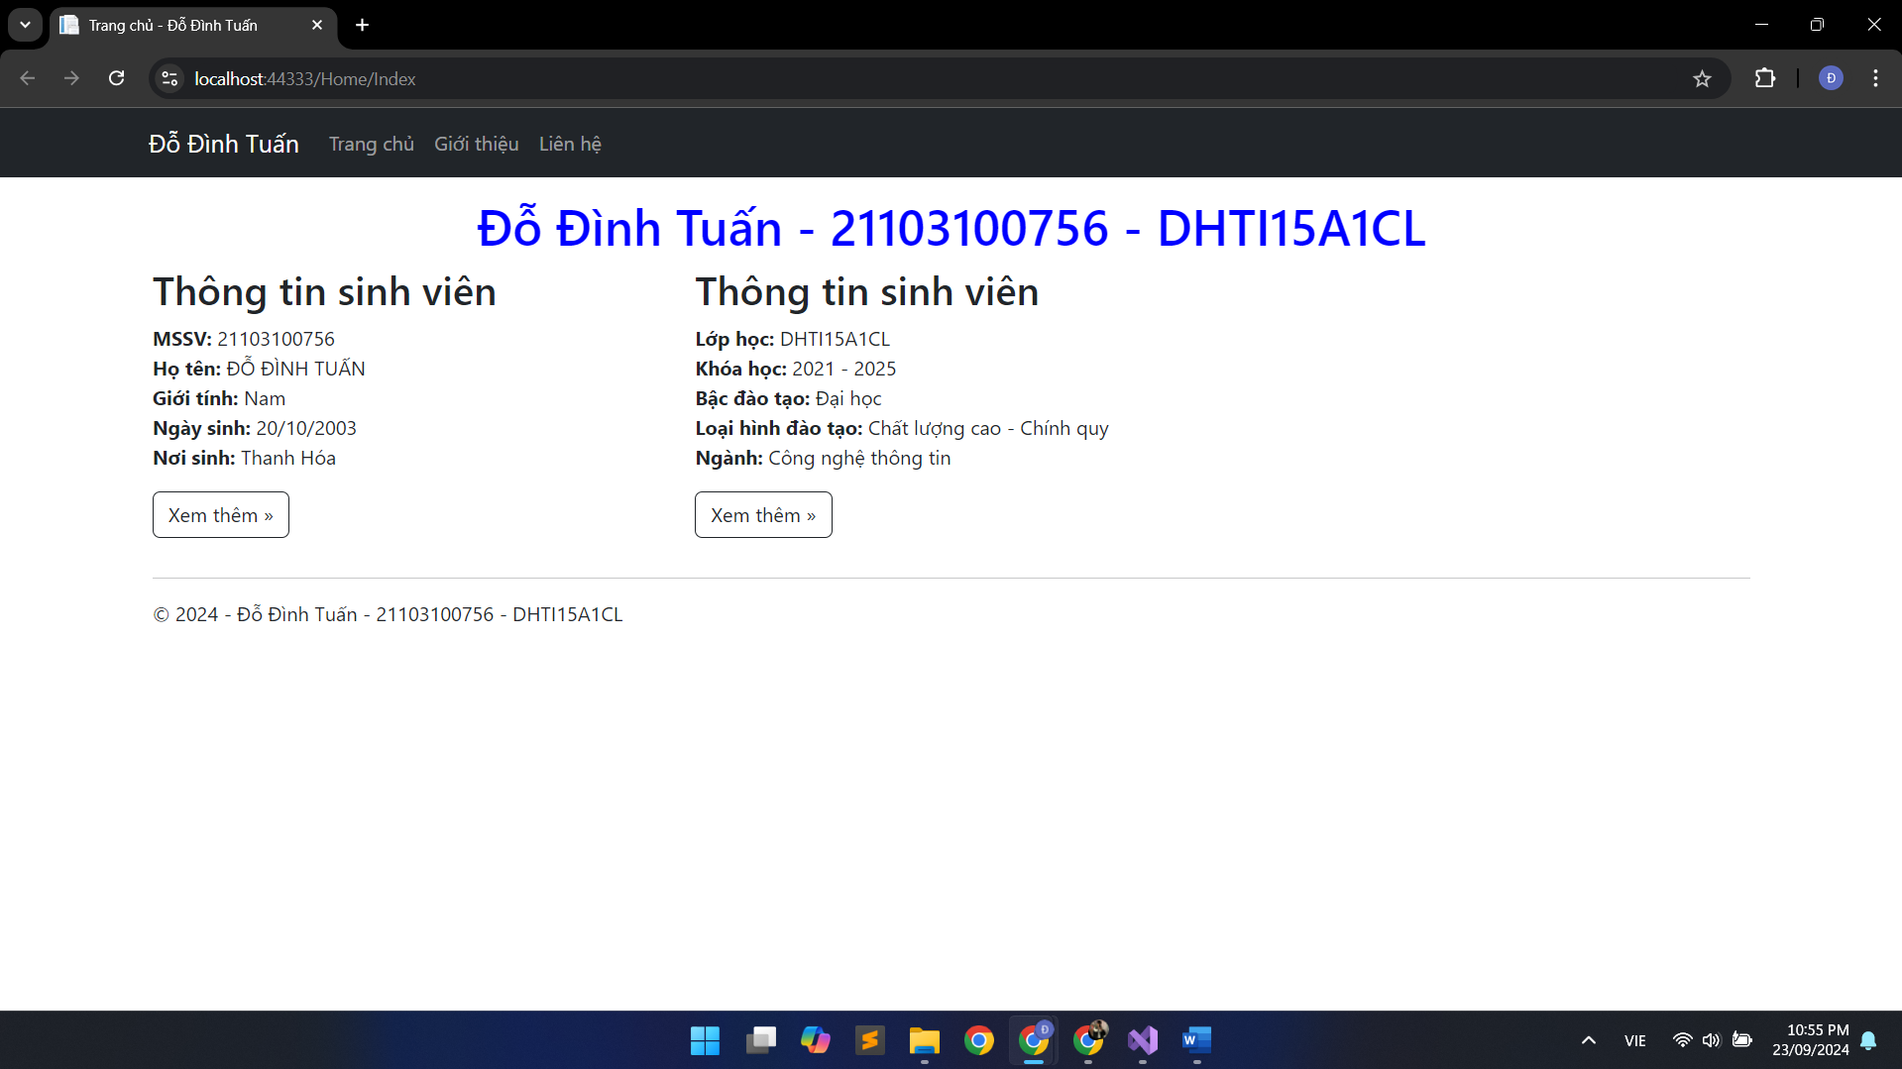

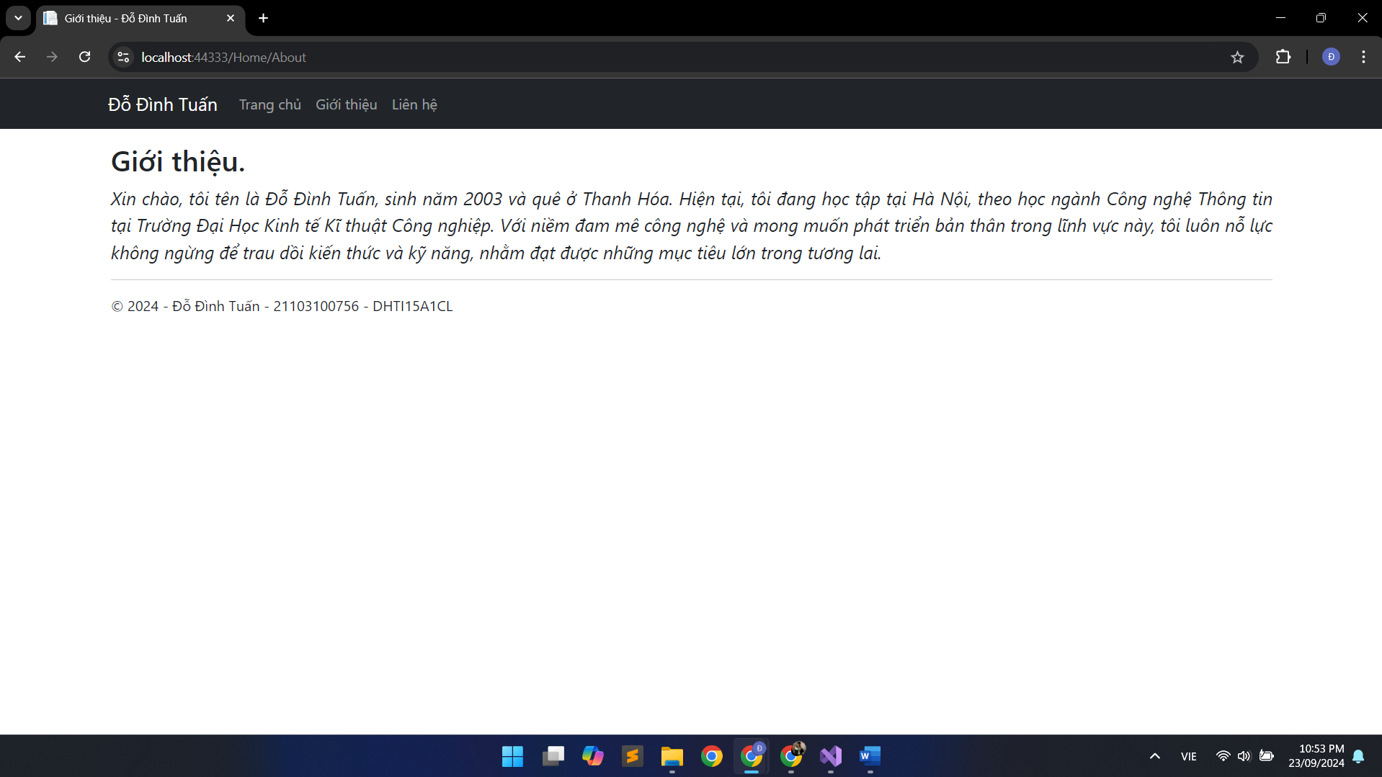

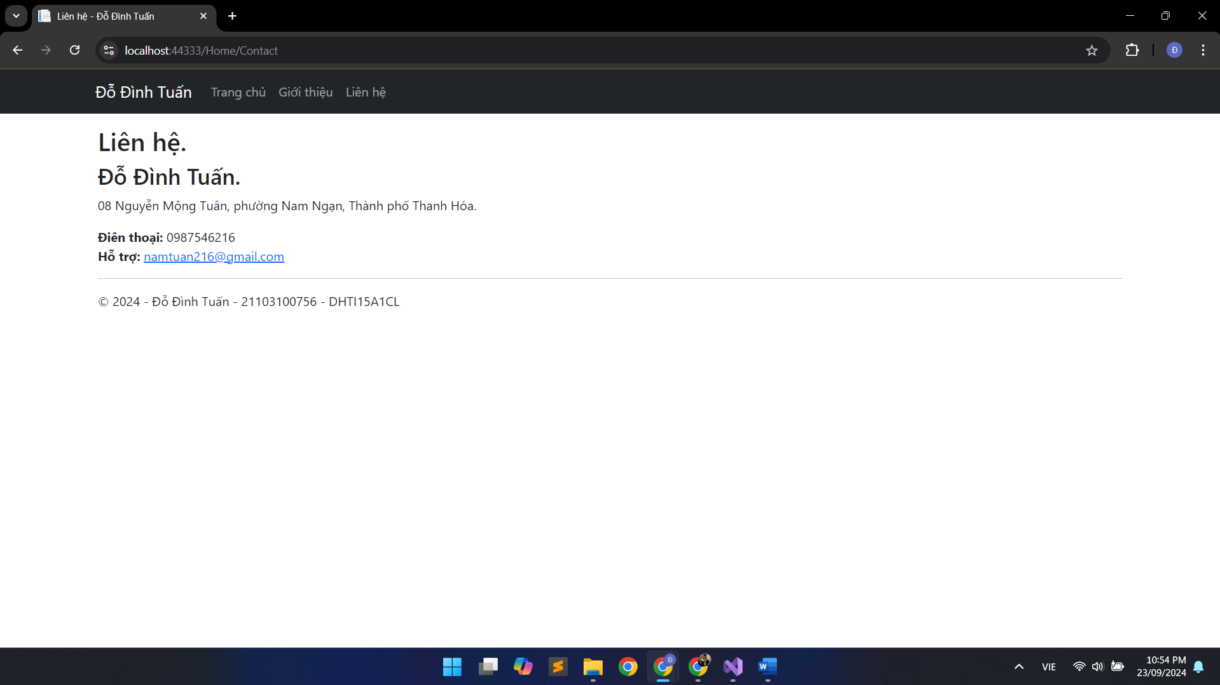

**Bài 2:**

